Project 2 Planning Exercise

Prepared by Nasreddine Hallam

This project planning exercise is part of the project 2 development process and therefore is graded. You must be present in the lab and collaborate with other members of your group to finish it. Only the group leader can submit this exercise.

Group 6

Project theme: product

Group members

Tang Jeremy : 2031746

Agluba Mark benedict :1533777

Tat Jacky : 1911748

Turdalieva Amina : 2035572

# Objectives:

* Understands the necessity of a project plan
* Examine the project specifications
* Determine the project scope and limits
* Identify project deliverables
* Set up an environment for coordination and collaboration between team members

# Understanding the problem

Carefully read the project specification and try to answer the following questions:

1. Will you be using front-end web development?

If yes, what are the development/coding technology will you be using?

Yes, we will be using html templates, css, JavaScript

1. Will you be using back-end web development?

If yes, what are the development/coding technology will you be using?

Yes, we will be using Django, python, postreSQL and Heroku for deployment.

1. What theme did you choose for your project?

Product

1. State the four applications of your project and briefly describe their corresponding functionalities
2. Website Administration Application

This application will be used by the superuser to manage the user groups: Members, User group, Item group, Super group

1. Website User Management Application

This application will be used to manage the Members users and visitors

1. Website Messaging Application

This application will be used for communication between Member users.

1. Website Item Catalog Application

This application will deal with the user interactions and manage the items.

1. Enumerate the main FIVE users (and their groups) of the system (Project)

Visitors, members, super group, item group, user group

1. For each user of the project, enumerate their major tasks/functionalities they will handle.

Or optionally, draw a (very simplistic) use case diagram

Visitors: the non-registered users

Members: clients who have registered

Super group: manages all registered users

User group: two users that superuser sets. They are responsible to access/manage members users.

Item group: consists of two users that are set by superuser, responsible to access/manage items.

# Project planning

1. In your own words, why do you think a project plan is necessary for this project? You may answer this question after you finish the whole exercise.

A project plan is necessary for this project, since it is a big project, and we want to be able to meet the deadlines. We also work in a big team and handle several applications; therefore, a good planning is necessary.

## Project task analysis and decomposition

1. What is the problem or purpose this project needs to address?

Developing a full stack web application that will handle user interactions and data handling.

1. List down the major tasks that make up your project

Creating the users

Creating and managing a database specific to users

Creating a messaging chat for member users

1. Break down the project into elaborated tasks (you do not have four major tasks only)

Members:

* Registering users
* Send private messages
* Browse items

Super User

* Manages members

Item group

* Manages items/ products

1. For each major task, break it down into more detailed task.

Members

* Registering users
* Log in / log out
* Resetting passwords
* Profile for each user
* Notifications
* Send private messages
* Comment on items
* Add items
* Delete / modify items
* Like / rate/ flag items
* See details of items
* (visitors and members) Browse / filter / search through items
* List items

Super user

* Adding new members into user group
* Warn/ flag members

Admin Item group

* Add new items
* Delete/modify/flag any item

1. You may draw a **Project Hierarchy Diagram** for the project tasks where:
   1. the root is the Project
   2. the leaves are detailed tasks
   3. Limit the depth of the tree.

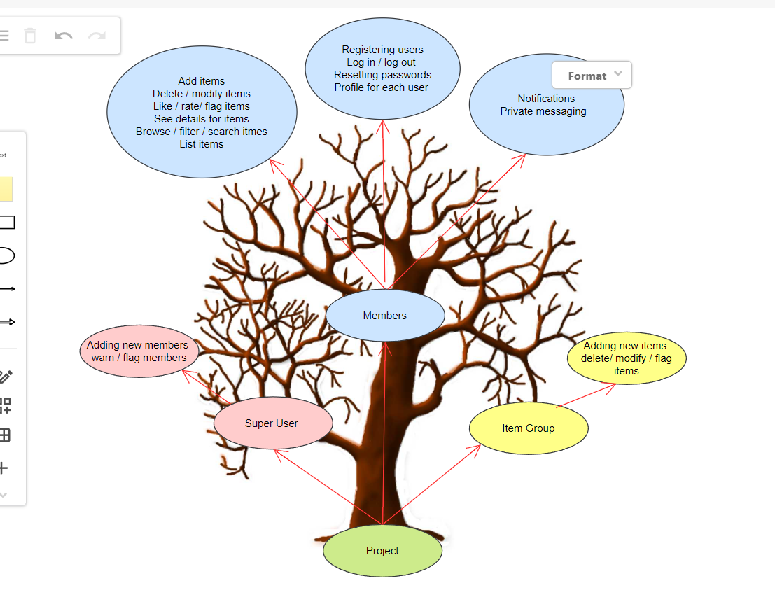

## Tentative Task Scheduling

1. Identify tasks are independents (and therefore can be concurrent)

Front-end part : the construction of the user interactions. The html, css, and user-client JavaScript.

Back-end: creating the whole project, user interactions is not necessary for program to work.

Members and Items groups that are independent and can be worked on simultaneously.

1. Identify Which tasks are dependents upon (completion) of other tasks

The item group depends on the managed database, that has to already exist.

The messaging chat needs members to already exist.

Members and visitors can only like, see, browse etc. items that already exist.

1. Estimate how much class time you can allocate to this project

4 classes of lab time, total of 12 hours.

1. Estimate how much non-class time you can allocate to this project

32 hours (8 hours per week)

1. Draw a tentative schedule. You can use **Gantt chart diagram**. Remember, tasks that are independent can be scheduled concurrently.
2. Assign team members to tasks.

Week 1:

* Registering users : Jeremy
* Log in / log out : Mark
* Resetting passwords : Jacky
* Profile for each user : Amina
* Add new items : Jeremy
* Set a database (create tables, relationships etc) : Mark
* Adding new members into user group : Jacky

Week 2:

* Comment on items : Amina
* Delete / modify items : Jeremy
* Like / rate/ flag items : Mark
* See details of items : Jacky

Week 3:

* (visitors and members) Browse / filter / search through items : Amina
* Warn/ flag members : Jeremy

Week 4:

* Notifications : Mark
* Send private messages : Jacky

## Project deliverables

These are specific products that will be produced by the project.

1. Enumerate all possible deliverables for this project (including this exercise).

12 April : Planning, creation of repo on git

Week 1 (24 April):

* Registering users
* Log in / log out
* Resetting passwords
* Profile for each user
* Add new items
* Set a database (create tables, relationships etc)
* Adding new members into user group

Week 2 (1 May):

* Comment on items
* Delete / modify items
* Like / rate/ flag items
* See details of items

Week 3 (8 May):

* (visitors and members) Browse / filter / search through items
* Warn/ flag members

Week 4 (13 May):

* Notifications
* Send private messages

## Code Project deliverables

These are specific products that will be produced by the project.

1. Enumerate all possible deliverables for this project (including this exercise).

## Setting up a collaborative environment

1. Appoint a group leader

* Jacky Tat

1. Briefly, enumerate the responsibilities of the group leader
   1. Only the group leader can communicate with the instructor via MIO.
   2. Submit the whole project
   3. Make sure that we keep on track, monitor the weekly work
   4. Create git repo
2. Enumerate the responsibilities of the other group members
   1. Meet the deadlines
   2. Weekly work
   3. Weekly report together
3. List communications means you plan to use between the group members

Discords / Instagram

1. Do you need to have meetings during the project development?

If yes how many? 1 weekly meeting

If yes, did you schedule them? during the lab on Tuesday

1. Create a git repo with your group members of your project.  
   include your instructor to your repo and send them the URL by MIO.  
   Send them the URL using MIO.

<https://gitlab.com/TatJacky/python-project-2.git>

1. Each member of the group should handle a project app, and therefore must use the feature branch model and open a Merge Request.
2. Appoint one group member (or the project leader) to review merge requests and approve if appropriate.